**High-Level Model of c5315**

**Statistics:** 178 inputs; 123 outputs; 2406 gates

**Function:** 9-bit ALU

This benchmark is an ALU that performs arithmetic and logic operations simultaneously on two 9-bit input data words, and also computes the parity of the results. Modules M6 and M7 each compute an arithmetic or logic operation specified by the control input bus CF[7:0]. Module M5 consists of multiplexers that route the results of M6 and M7 and four input buses to its four outputs. Output buses OF1 and OF2 can also be set to **logic 0** by MuxSel[8]. Modules M3 and M4 compute the parity of the result of the operation given by CP=CF[7:4]. Module M5 contains four multiplexers which direct the parity results and an additional set of four inputs to its outputs. The adders in M6 and M7 as well as the parity logic for the arithmetic operations in M3 and M4 use a carry-select scheme with 4-bit (low-order) and 5-bit (high-order) blocks. The circuit also includes logic for calculating various zero and parity flags of the input buses.

[**Inputs/Outputs vs. Netlist numbers**](http://web.eecs.umich.edu/%7Ejhayes/iscas.restore/c5315/c5315.html#pgfId=1008955)

**Models:**

* I. Original ISCAS gate-level netlist
  + [in ISCAS-89 format](http://web.eecs.umich.edu/%7Ejhayes/iscas.restore/c5315/c5315.isc)
  + [in Verilog](http://web.eecs.umich.edu/%7Ejhayes/iscas.restore/c5315/c5315gate.v)
* II. [Verilog hierarchical netlist](http://web.eecs.umich.edu/%7Ejhayes/iscas.restore/c5315/c5315high.v) (functionally equivalent to I)
* III. [Verilog flat netlist](http://web.eecs.umich.edu/%7Ejhayes/iscas.restore/c5315/flat5315.v) (flat version of II; functionally equivalent to I, but with minor structural differences)

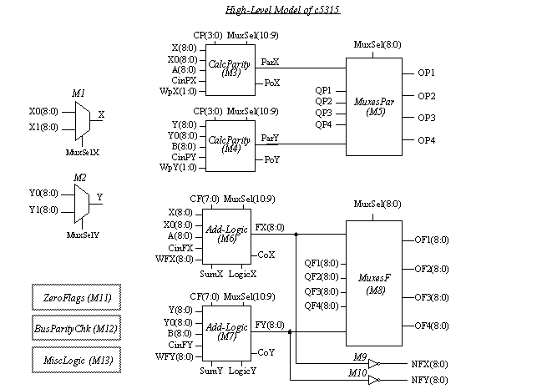

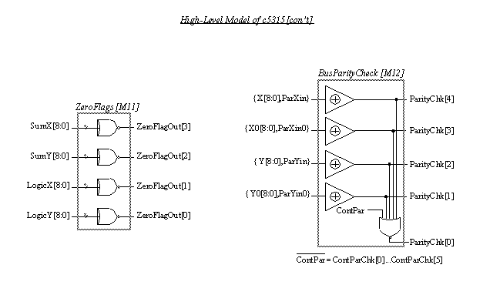

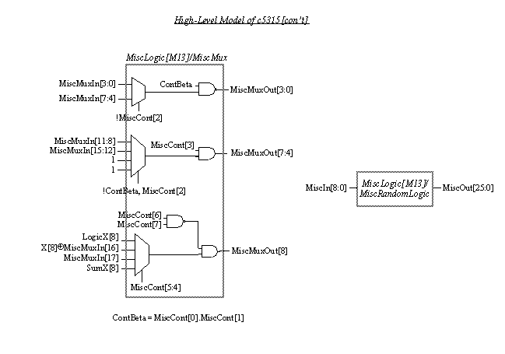

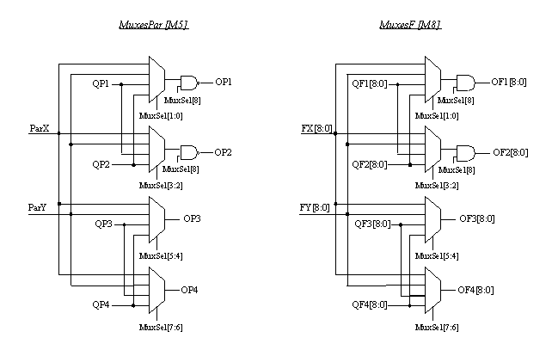

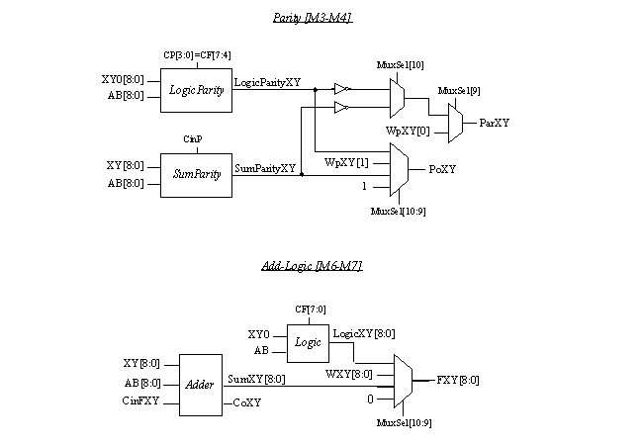

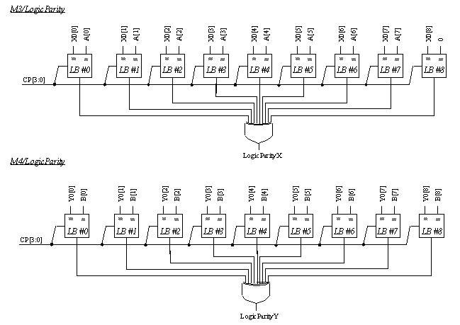

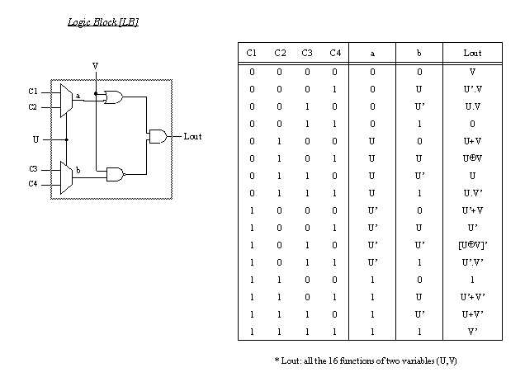

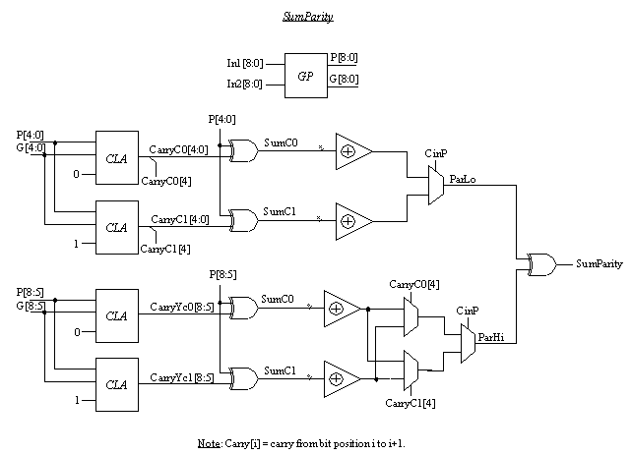

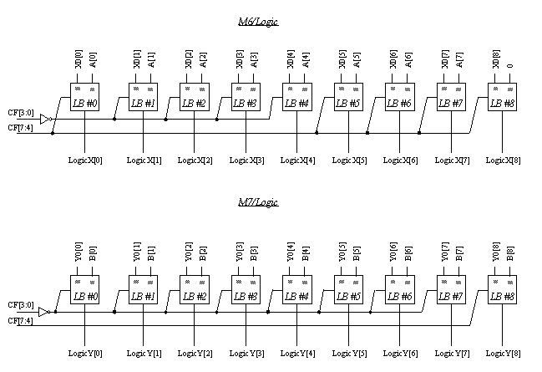

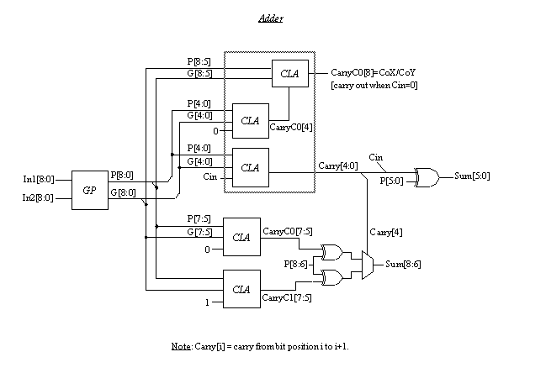

|  |  |
| --- | --- |
| Input | Line number |
| X0[8:0] | 293, 302, 308, 316, 324, **logic 1**, 341, 351, 361 |
| X1[8:0] | 299, 307, 315, 323, 331, 338, 348, 358, 366 |
| MuxSelX | 332 |
| A[8:0] | **logic 1**, **logic 1**, 479, 490, 503, 514, 523, 534, **logic 1** |
| Y0[8:0] | 206, 210, 218, 226, 234, 257, 265, 273, 281 |
| Y1[8:0] | 209, 217, 225, 233, 241, 264, 272, 280, 288 |
| MuxSelY | 335 |
| B[8:0] | 446, 457, 468, 422, 435, 389, 400, 411, 374 |
| CinFX, CinFY | 54, 4 |
| CinPX,CinPY | 2174, 1497 |
| WpX[1:0] | 120, 94 |
| WpY[1:0] | 118, 97 |
| QP1,QP2,QP3,QP4 | 176, 179, 14, 64 |
| Q1[8:0] | 191, 194, 197, 203, 200, 149, 155, 188, 182 |
| Q2[8:0] | 161, 164, 167, 173, 170, 146, 152, 158, 185 |
| Q3[8:0] | 109, 46, 100, 91, 43, 76, 73, 67, 11 |
| Q4[8:0] | 106, 49, 103, 40, 37, 20, 17, 70, 61 |
| WFX[8:0] | 123, 121, 116, 112, 52, 130, 119, 129, 131 |
| WFY[8:0] | 115, 114, 53, 113, 122, 128, 127, 126, 117 |
| MuxSel[10:0] | 4091, 4092, 137, 4090, 4089, 4087, 4088, 1694, 1691, 1690, 1689 |
| CF[7:0] | 248, 251, 242, 254, 3552, 3550, 3546, 3548 |
| CP[3:0]=CF[7:4] | 248, 251, 242, 254 |
| ParYin= MuxSelY ? ParYin0 : ParYin1  (ParYin0, ParYin1) | 289, 292 |
| ParXin= MuxSelX ? ParXin0 : ParXin1  (ParXin0, ParXin1) | 369, 372 |
| ContParChk[5:0] | 562, 245, 552, 556, 559, 386 |
| MiscMuxIn[17:0] | 123 (=WFX[8]), 132, 23, 80, 25, 81, 79, 82, 24, 26, 86, 83, 88, 88, 87, 83, 34, 34 |
| MiscContIn[7:0] | 4115, 135, 3717, 3724, 141, 2358, 31, 27 |
| MiscIn[8:0] | 545, 549, 3173, 136, 1, 373, 145, 2824, 140 |

|  |  |
| --- | --- |
| Output | Line number |
| OP1,OP2,OP3,OP4 | 658, 690, 767, 807 |
| OF1[8:0] | 654, 642, 651, 648, 645, 670, 667, 664, 661 |
| OF2[8:0] | 688, 676, 685, 682, 679, 702, 699, 696, 693 |
| OF3[8:0] | 727, 747, 732, 737, 742, 752, 757, 762, 722 |
| OF4[8:0] | 712, 787, 772, 777, 782, 792, 797, 802, 859 |
| NXF[8:0] | 824, 826, 828, 830, 832, 834, 836, 838, 822 |
| NYF[8:0] | 863, 865, 867, 869, 871, 873, 875, 877, 861 |
| CoX,CoY | (629, 618) [*](http://web.eecs.umich.edu/%7Ejhayes/iscas.restore/c5315/c5315.html#pgfId=1013809) , (591, 621) [*](http://web.eecs.umich.edu/%7Ejhayes/iscas.restore/c5315/c5315.html#pgfId=1013809) |
| PoX,PoY | 843, 882 |
| ParityChk[4:0] | 998, 1002, 1000, 1004, 854 |
| ZeroFlagOut[3:0] | 585, 575, 598, 610 |
| MiscMuxOut[10:0] | 623, 813, 818, 707, 715, 639, 673, 636, 820, 717, 704 |
| MiscOut[25:0] | 593, 594, 602, 809, 611, 599, 612, 600, 850, 848, 849, 851, 887, 298, 926, 892, 973, 993, 144, 601, 847, 815, 634, 810, 845, 656 |

*. (a,b): a,b are identical outputs.